ELEC-2110

Electric Circuit Analysis

FROM: Jacob Howard

TO: Markus Kreitzer

DATE: February 19, 2020

LAB SECTION: 002

***Recitation, MATLAB, and Simulink:***

***First-order Transient Circuits***

# Introduction

The Objective of this lab was to practice more with Multisim and Matlab with an introduction to first order transient circuits. We use Multisim and matlab to show the graphs of the transient circuits.

# Exercise 1

In exercise 1, we were asked to construct the circuit in Figure 1 in Multisim and plot the graph of I0(t) in Mutlisim and Matlab. Figure 1 is shown below. Figure 2 shows the circuit constructed in Multisim and the graphs are shown in graph 1 and 2. I0(t) is shown how to calculate based on time below in table 1

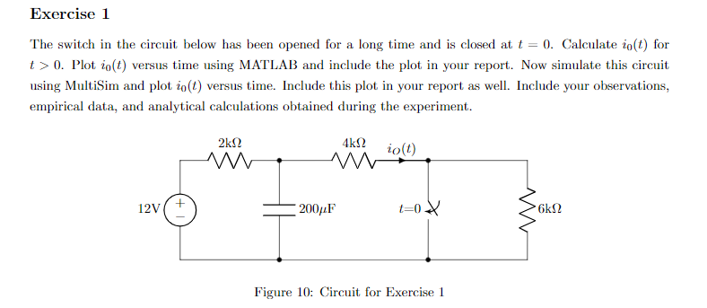

*Figure 1*

|  |  |
| --- | --- |
| **I0(t)** |  |

*Table 1*

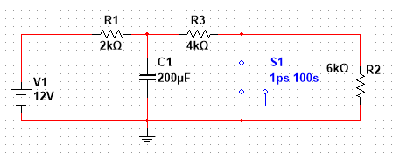

*Figure 2*

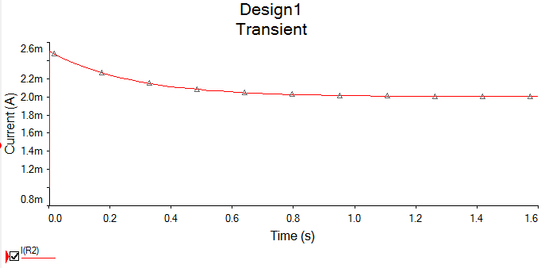

*Graph 1 (Multisim Graph)*

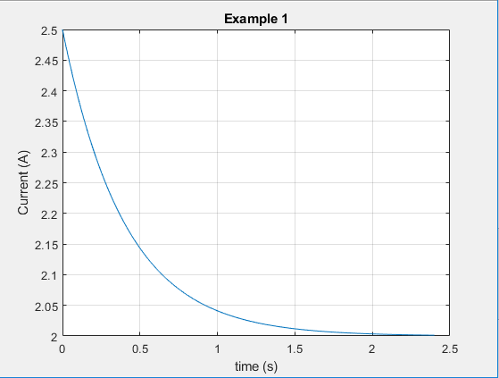

*Graph 2 (Matlab graph)*

# Exercise 2

In exercise 2, we were asked to do the same thing as in exercise 1, but we must use the circuit in figure 3 shown below. Figure 4 shows the circuit constructed in Multisim and graph 3 shows the graph. Graph 4 shows the Octave graph. Table 2 shows I0(t) at any time.

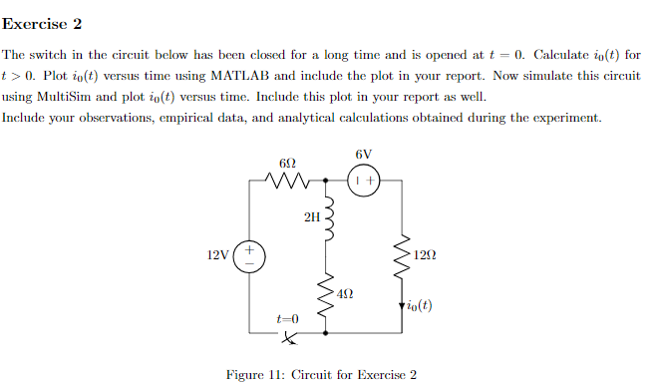

*Figure 3*

|  |  |
| --- | --- |
| **I0(t)** |  |

*Table 2*

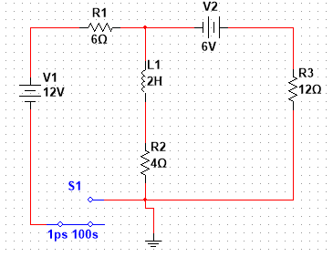

*Figure 4*

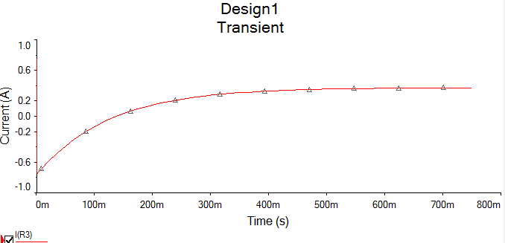

*Graph 3*

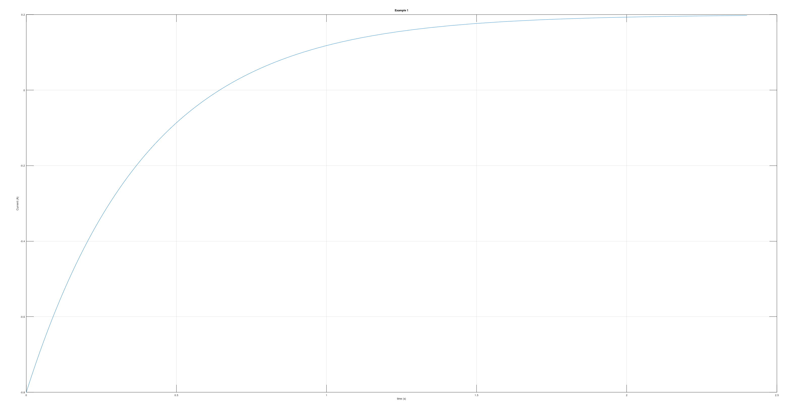

*Graph 4 - Ovtave Graph (Not sure how to change text size)*

# Exercise 3

In exercise 3, it tells us that the switch in Figure 5 below has been closed for a long time and is opened at t = 0 [1]. Figure 6 shows the circuit constructed in Multisim and graph 5 and 6 shows the graph. Table 3 is the formula for V0(t).

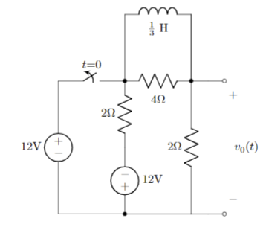

*Figure 5*

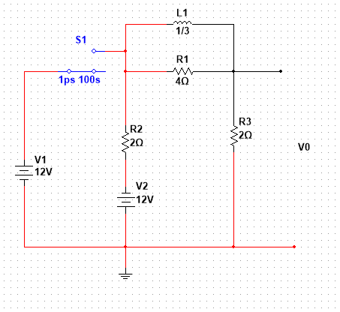

*Figure 6*

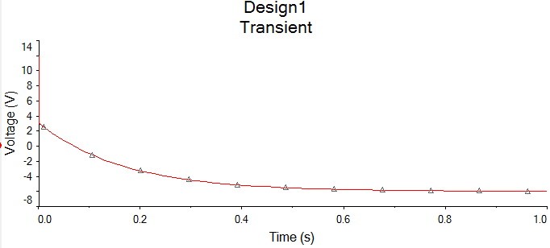

*Graph 5*

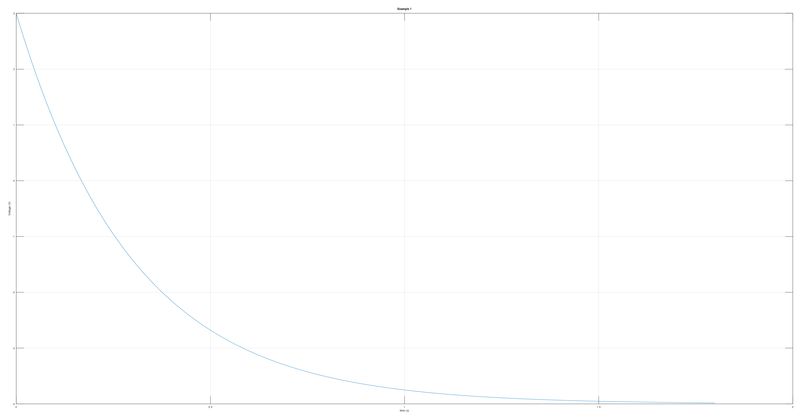

*Graph 6 – Octave Graph*

|  |  |
| --- | --- |
| **V0(T)** | 60e-6t – 48 V |

*Table 3*

# Exercise 4

In exercise 4, it tells us that The switch in Figure 7 below has been open for a long time and is closed at t = 0 [1]. We must find V0(t) and plot the graphs in Multisim and Matlab. Figure 8 shows the circuit constructed in Multisim and Graph 7 graph. Table 4 is the formula of V0(t).

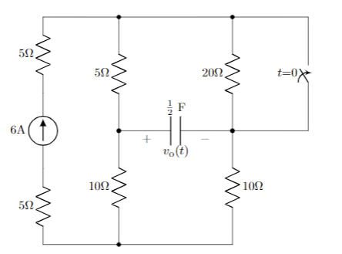

*Figure 7*

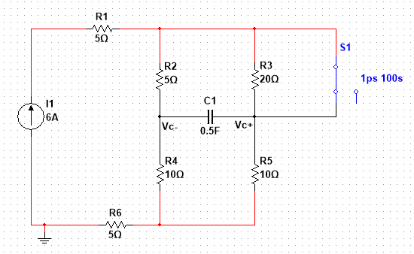

*Figure 8*

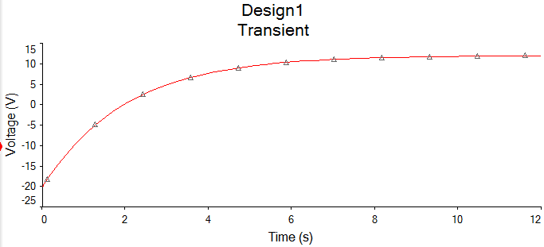

*Graph 7*

|  |  |
| --- | --- |
| **V0(T)** | -12 + 32e-t/2 V |

*Table 4*

# Conclusion

This lab was used as an recitation for Matlab and Multisim, while introducing first-order transient circuits. I did run into some trouble with the graphs being incorrect, but the TA was very helpful on showing us how to get the correct graph.

# Bibliography

[1] Nelms, R. Mark, and Elizabeth Devore, Revised by Markus Krietzer. *Recitation & MultiSim: Thevenin’s and Norton’s Theorems*. 2020, p. 5, Accessed 19 Feb 2020.